Problem 2 – Joro the Rabbit

Joro is a rabbit. But he is no ordinary rabbit – he just loves to jump around. But jumping around without any precalculated direction is too ordinary, so he likes jumping in just a given direction and to make it more fun, the jumping is done in a circle. By given terrain, help Joro find longest fun and not ordinary route of jumps.
You are given the terrain as sequence of numbers. The terrain should form a circle, so the last number is before the first, and the first is after the last.
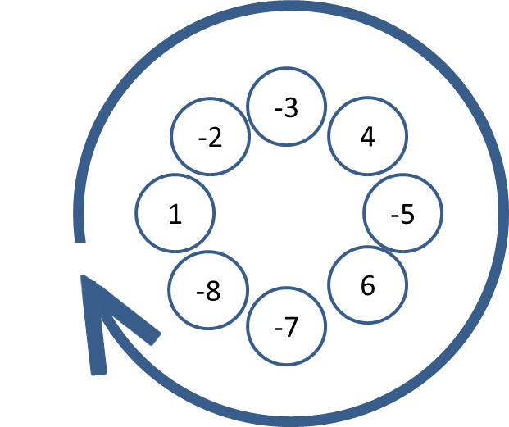
Joro can enter the terrain from every position, jump only on numbers larger than the one he is on, only in direction left-to-right and with the same step. Joro’s jumping steps range from 1 to the size of the terrain. Joro cannot jump on position that he already visited.
Example:
In the sample above, the best route is -7, -5, -3, 1 with length 4 and step 6.
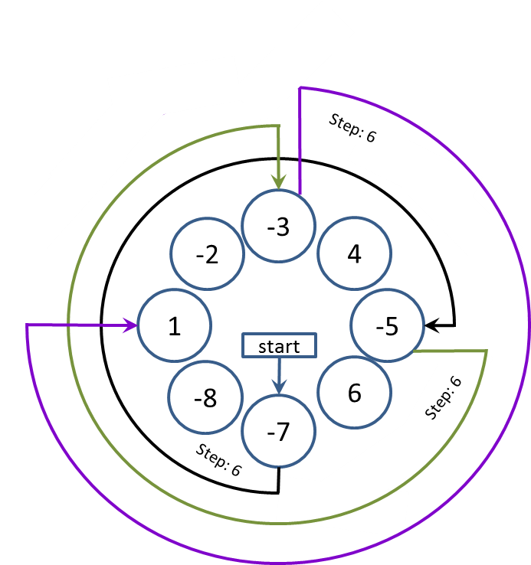

Input
The input data should be read from the console.
On the first line you will be given the terrain- numbers separated with “, ” (comma and space).

Output
The output data should be printed on the console.
The output should contain the maximal number of positions visited by Joro, using any of the possible steps.

Constraints
- The numbers in the terrain will be between 1 and 2 500 inclusive.
- Each of the numbers in the terrain will be between -1000 and 1000
- Allowed working time for your program: 0.2 seconds. Allowed memory: 16 MB.

Examples
Input example | Output example
1, -2, -3, 4, -5, 6, -7, -8 | 4
1, 2, 3, 4, 5, 6, 7, 8, 9, 10, 0 | 11
1, 1, 1 | 1

